# ELECTRONIC VOTING MACHINE

##### **Srinidhi S*, Meghana Badiger**, Praveen P**,** **Bhuvaneshwar C***, RASHMITHA N****, JASWANTH KUMAR\*\*\*\*\***

* Computer Science Engineering, Presidency University, Bengaluru

** Electronics and communication Engineering, Presidency University, Bengaluru

***Abstract*:** There are many new technologies in the voting system. Our India is a Democratic country and the specialty our country is VOTE by which people vote their favorite Candidate to serve the nation. The main drawback of the voting system is faking votes, multiple times vote by same candidate voting, there is no proper security while counting the votes, political influence. Our government has Aadhar Card which has full details of the candidate’s i.e., Name, DOB, Address, Fingerprint of the candidate, Facial recognition these all are stored in particular government database.

Keywords: Raspberry pi, Fingerprint module, LCD

1. Introduction

The Biometric is the recognition or identification of individuals who are under observation. Biometric is a science and technology that measures and examines the human activities or body characteristics i.e., finger print, facial recognition, eye retinas and irises, voice design for identification purpose. Nowadays Biometric devices are used many fields such as security purpose, banks, colleges, universities and many more. In this paper, the Biometric technology usage in e-voting machine is explained. Earlier, voting process was done using paper chit and pen on that time there is a misleading in the when counting the votes for this reason who got more votes become lose and nation goes to wrong hands. So, for this reason government is updating in the electric voting process. For avoiding the threats in election process such as security, human errors political parties, so solution for these problems we are introducing the electric voting machine using biometric technology.

TYPES OF VOTING**:** In the world compare to China India has more votes or voting systems. We are using more voting frameworks. The four methods for voting follow:

* Voice vote
* Division vote
* Yea and Nay Vote
* Record Vote

Elections in India are conducted almost exclusively using electronic voting machines developed over the past two decades by a pair of government-owned companies. These devices, known in India as EVMs, have been praised for them simple ease of use, and reliability.

1. General-description

Overview of the system

There are several methods available to carry out verification process. Out of several processes biometric verification is the most secured process. But in the existing systems only either of the biometrics are used. The security cannot be ensured in these processes. Also, these methods have not been implemented successfully. Read already published work in the same field.

The paper will give an overview of a Biometric Voting System (BVS) which will access the data stored in the database of Aadhaar card, a Government Id card for each

citizen in India, while casting their votes.

While issuing the Aadhaar card a citizen of India needs to give his/her unique biometric data i.e., the fingerprint image and iris image of both eyes to the government.

The BVS is integrated with a biometric fingerprint machine for the authentication of a genuine voter on the Election Day by comparing the given image with the already stored fingerprint image of that voter.

1. PROPOSED SYSTEM

The voter ID card is replaced with which serves as an access to the individual on the day of voting. During the day of voting the voter undergoes a three-step verification process. The first step is one in wherein the voter has to show his card and it is read by a reader module. The reader module senses the card and displays the details of the individual on the LCD screen. Once after the details are displayed the voter is asked to place his/her registered finger on the fingerprint sensor. The sensor module verifies the fingerprint with the existing database and permits the user to next level of verification process if the details match else the LCD displays “wrong user”. Once after the fingerprint matches, the camera turns on for the face recognition and captures the image of the person 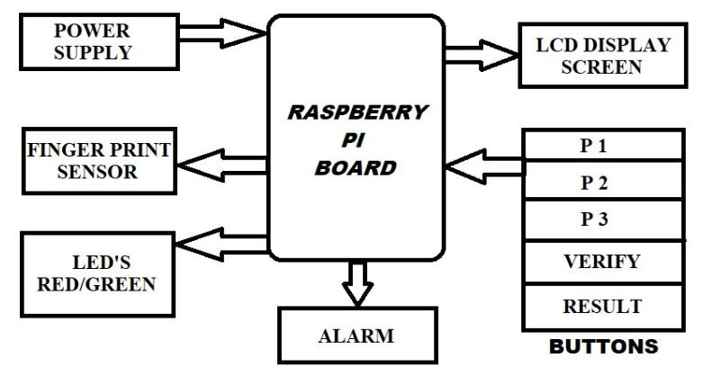and matches it with the existing database. If the images also matches then the door of ballot booth opens for the voter to cast his vote and the votes are simultaneously on the monitor. Thus, this process provides a much secured three level verification process and the illegal practices during the day of voting are also avoided.

1. LITERATURE SURVEY

Jambhulakar, chakole and pradhi proposed a novel security for online voting system by using multiple encryption schemes. Multiple encryptions to avoid DOS attack. This paper use cryptography concepts to take pros of digital signature. After sending encrypted vote then server side decrypt the vote before counting.

2. Pashine, ninave and kelapure proposed an android platform for online voting system. This application provides diversion of long process also provide security to the voter and he can vote easily at his hometown itself.

This also contains three panels:

1. Admin panel

2. Candidate panel

3. Voter panel

3.Shridharan Implemented three models such as,

Authentication model, franchise excising model, distributed database and central server model. In authentication model voter with smart card and voter identification number and also gives the biometric information.

In such a system, the correctness burden on the voting terminal’s code is significantly less as voters can see and verify a physical object that describes their vote and are allowed to vote in terminal only after their identity is proved.

4.Himanshu Agarwal and Gynandry proposed Aadhar id based online voting system for Indian election is proposed for the first time in this paper. The proposed model has a greater security in the sense that voter high security password is confirmed before the vote is accepted in the main database of Election Commission of India.

5.Gianluca Dini [10] This proposed system is based on replication and tolerates both benign and fully arbitrary failures of servers.

1. EXPERIMENTAL SETUP

BLOCK DAIGRAM:

1.Raspberry Pi board:

Raspberry pi series of small single-board computers developed in the United Kingdom by the raspberry pi foundation.

In this model/ project we are using Raspberry Pi 4 Model B will have learned what your face look like. It offers ground-Breaking increases in processor speed, multimedia performance, memory,

and connectivity compared to the prior-generation Raspberry pi 0 model W while retaining backwards compatibility and similar power consumption.

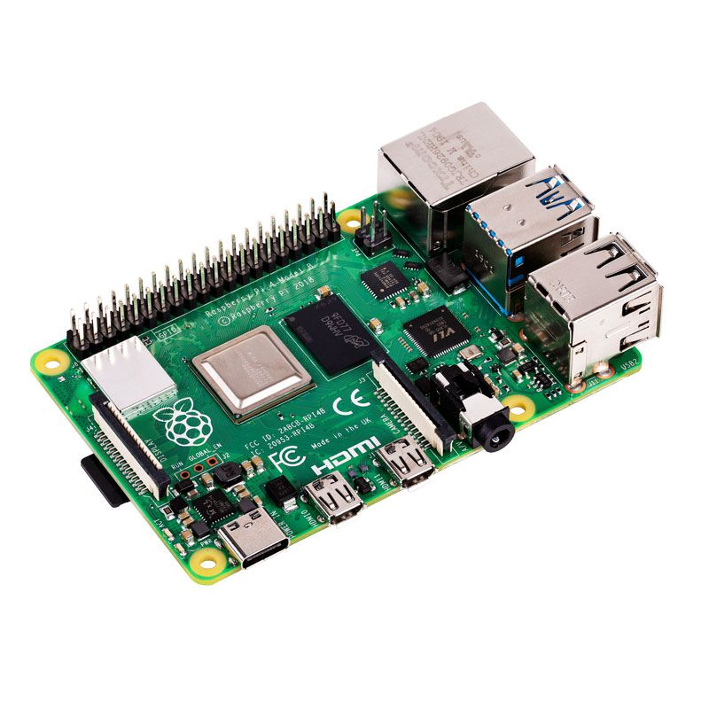

2.Power supply:

The official raspberry pi micro supply is designed to be the most reliable source of power for the raspberry pi.

3.Fingerprint sensor:

This is the main part of our model. Here the fingerprint used as the biometric information. It allows the user to scan the fingerprint in order to check his eligibility. In this model or project, we are using Finger print R307 Model, which has the capacity of 1000 fingerprints.

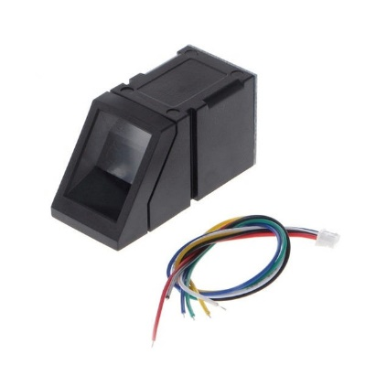

4.Led’s Red/Green:

Once the fingerprint scanning is done, if the fingerprint is verified it indicates the green LED or else indicates the Red LED.

FLOWCHART:

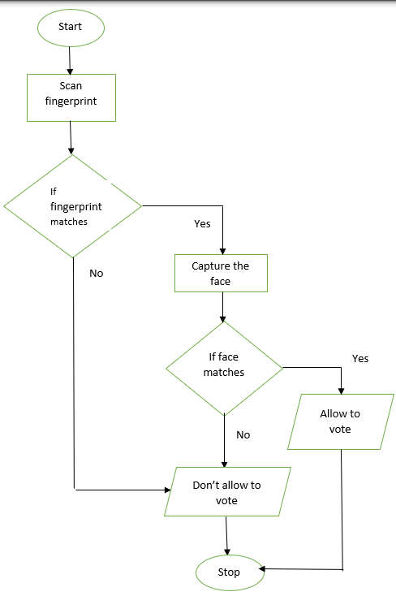

Step 1: Start the voting process

Step 2: Candidate should place the finger on the fingerprint sensor

Step 3: If the fingerprint matches the register fingerprint, then the candidate is allowed to capture the face, otherwise the LCD display shows the message don’t allow to vote and there will be beep sound produced.

Step 4: Once the fingerprint matches, the candidate will be allowed to capture the face. If the face matches with the register face, then LCD display the shows the message allowed to vote, if the face doesn’t match then the LCD display the don’t allow to vote and there will be a beep sound then the candidate will have to terminate the voting process.

1. CONCLUSION

The main moto of the project is to stop the voting manipulation and scams. Through this project there will be an advancement in the voting process. Since the voting machine will have the fingerprint scanner and facial recognition which helps in regulating the duplicating votes. India will be democracy country as people choose the right leader this project will not serve injustice towards any political party and it will be a fair process.

References

[1] Umang Shah, Trupt Shah, Marteen Kansagara, Saagar Daxini, „Biometric Secured Voting Machine to Avoid Bogus Voting Based on AADHAR CARD‟ , International Journal of Innovative Research in Computer and Communication Engineering , Vol. 3, Issue 3, March 2015 [2] Rudrappa B. Gujanatti, Shivaram N. Tolanur, Murughendra S. Nemagoud, Shanta S. Reddy, Sangameshwar Neelagund, ‟ A Finger Print based Voting System‟ , International Journal of Engineering Research & Technology (IJERT), ISSN: 2278-0181. Vol. 4 Issue 05, May-2015

[3] M.Sudhakar, B.Divya Soundarya Sai,‟ Biometric System Based Electronic Voting Machine Using Arm9 Microcontroller„ IOSR Journal of Electronics and Communication Engineering (IOSR-JECE) e-ISSN: 2278- 2834,p- ISSN: 2278-8735.Volume 10, Issue 1, Ver. II (Jan - Feb. 2015)‟

[4] Soumyajit Chakraborty, Siddhartha Mukherjee, Bhaswati Sadhukhan, Kazi Tanvi Yasmin, ‟ Biometric Voting System using Aadhar Card in India „, International Journal of Innovative Research in Computer and Communication Engineering (An ISO 3297: 2007 Certified Organization) Vol. 4, Issue 4, April 2016 ‘.